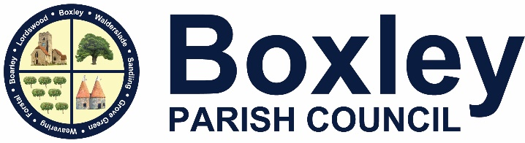

Notice of conclusion of the audit
Annual Return for the year ended 31st March 2024
____________________________________________________________________

Section 25 of the Local Audit and Accountability Act 2014. Accounts and Audit (England) Regulations 2015

The audit of accounts for Boxley Parish Council for the year ended 31 March 2024 has been concluded.
The Annual Governance and Accountability Return is available for inspection by any local Government elector of the area of Boxley Parish Council on application to:
The Parish Clerk – Mrs D Baylis
Boxley Parish Council
Beechen Hall
Wildfell Close
Walderslade
Kent
ME5 9RU
01634 861237

Copies will be provided to any local government elector on payment of £10 for each copy of the Annual Return.
Announcement made by: Mrs D Baylis
Date of announcement: 2 September 2024

